SMART WASTE MANAGEMENT

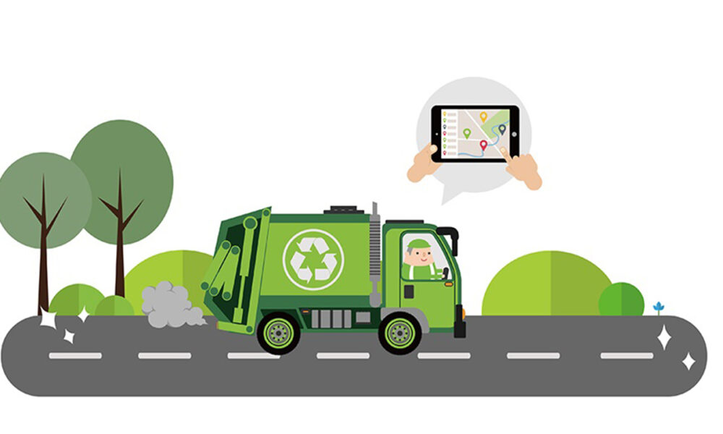

PROJECT PLANING II

|  |  |
| --- | --- |
| **DATE** | **24.10.2022** |
| TEAM ID | **PNT2022TMID34358** |
| **PROJECT NAME** | **SMART WASTE MANAGEMENT FOR METROPOLITAN CITIES** |
| **MAXIMUM NUMBER** | **4 MARKS** |

**TEAM LEADER**

* MEENAKSHI.R

**TEAM MEMBER:**

* Kavitha.s
* MARY JAVKEY RUHISHA.S
* LIBISHA.K.J

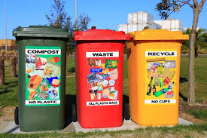TECHNOLOGY ARCHITECTURE

***Think outside the trash..******Recycle!******Don't throw money in the trash – recycle all – it's your decision..!!!***

**Technology Stack (Architecture & Stack) :**

|  |  |
| --- | --- |
| Date | 28 October 2022 |
| Team ID | PNT2022TMID34358 |
| Project Name | Smart Waste Management System For Metropolitan Cities |
| Maximum Marks | 4 Marks |

**Technical Architecture :**

**Table -1: Components & Technologies**

|  |  |  |  |
| --- | --- | --- | --- |
| **S.No** | **Components** | **Description** | **Technology** |
| 1. | User  Interface | Web Portal | HTML,CSS,NodeRed,  Javascript. |
| 2. | Application Logic-1 | Tocalculatethedistance of dreck and show the real time level in web portal , information getting via ultra sonic sensor and the alert message activate with python script to web porta**l.** | Ultrasonic sensor/ Python. |
| 3. | Application Logic-2 | To calculate the weight of the garbage and show the real time weight in web portal, this info getting via load cell and the alert message activate with python to web portal. | Loadcell**/**Python |
| 4. | Application Logic-3 | GettinglocationoftheGarbage**.** | GSM/GPS. |
| 5. | Cloud  Database | Database Service on cloud. | IBM DB2, IBM Cloudant etc.. |
| 6. | File  Storage | File Storage requirements. | GitHub, Local file System. |
| 7. | External API-1 | Firebase is a set of hosting services for any type of application | Firebox. |
|  |  | It offers NoSQL and real-time hosting of databases, content, social authentication, and notifications, or  services, such as a realtime communication server. |  |
| 8. | Ultrasonic Sensor. | To throw alert message when garbage is getting full.  Distance Recognition Model. | Distance Recognition Model. |
| 9. | Infrastructure (Server/Cloud). | Application Deployment on Local  System / Cloud Local  Server  Configuration: localhost  Cloud Server  Configuration: localhost,  Firebox | Localhost, Web portal. |

**Table-2: Application Characteristics:**

|  |  |  |  |
| --- | --- | --- | --- |
| **S No** | **Characteristics** | **Description** | **Technology** |
| 1. | Open -Source Framework | NodeRed**,**Python**,**IBMSimulator**.** | Iot. |
| 2. | Security Implementation | Raspberry Pi is connected to the internet and for example used to broadcast  live data, further security  measures are recommended  and use the  UFW(uncomplicated  Firewall). | Iot. |
| 3. | Scalable Architecture | Raspberry pi:Specifications  Soc: rspi ZERO W  CPU: 32-bit computer with a  1 GHz ARMv6  RAM: 512MB | Iot. |
|  |  | Networking: Wi-Fi Bluetooth: Bluetooth 5.0, Bluetooth Low Energy (BLE).  Storage: MicroSD  GPIO: 40-pin GPIO header, populated  Ports: micro HDMI 2.0,  3.5mm analogue audiovideo jack, 2x USB 2.0, 2x USB 3.0, Ethernet Dimensions: 88mm  x 58mm x 19.5mm, 46g |  |
| 4. | Availability | These smart bins use sensors like ultrasonic and load cell to send alert message about the trash level recognition technology, and artificial intelligence, enabling them to automatically sort and categorize recycling litter into one of its smaller bin. | Iot. |
| 5. | Performance | Number of request:RPI manages to execute 129-139 read requests per  second.Use of Cache:512mb  Use of CDN’s:Real time | Iot/web portal. |

...< >…